Experiment 07
Configuration and Use of Network Devices

Lab Objective:
To configure and understand the functions of various network devices such as routers, switches, and hubs, and learn their role in a network setup.

Prerequisites:
- Basic understanding of networking concepts (e.g., IP addressing, data transmission).
- Familiarity with network configuration commands and tools (e.g., Cisco Packet Tracer, command line interface, IP configuration).

Outcome:
By the end of this experiment, students will be able to:
- Identify different network devices (router, switch, hub).
- Understand how they function in a network.
- Successfully configure routers and switches using commands/tools.
- Demonstrate data flow through a simple network.

1. Hub
- Definition: A hub is a basic networking device that connects multiple computers in a LAN.
- Function: It simply broadcasts data to all ports, regardless of the destination.
- Type: Physical Layer device (Layer 1 of OSI model).
- Working: When a data packet arrives at one port, it is copied to all other ports.
- Configuration:
No configuration needed — plug and play.
- Advantages:
  - Cheap and easy to use.
- Disadvantages:
  - No intelligence (no MAC filtering).
  - Causes network congestion.
- Use Case: Small or temporary networks for testing.

2. Switch
- Definition: A switch is a networking device that connects devices in a LAN and uses MAC addresses to forward data only to the intended device.
- Function: Makes decisions based on the destination MAC address.
- Layer: Data Link Layer (Layer 2).
- Working:
  - Maintains a MAC address table.
  - Learns the devices connected to each port and sends data to the correct port.
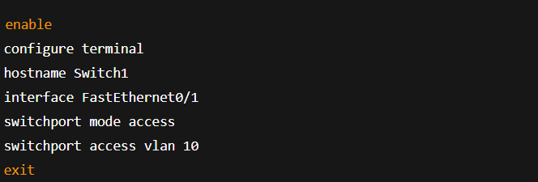
- Basic Configuration (using CLI):

- Advantages:
  - Reduces network traffic.
  - More secure than hubs.
- Disadvantages:
  - More expensive than hubs.
- Use Case: Office or campus LAN environments.

3. Router
- Definition: A router is a device that connects multiple networks and forwards data packets between them based on IP addresses.
- Function: Routes data between different networks (e.g., LAN to WAN).
- Layer: Network Layer (Layer 3).
- Working:
  - Uses routing tables and routing protocols (RIP, OSPF) to determine the best path.
- Basic Configuration (using CLI):
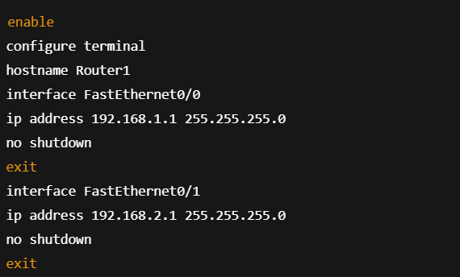
- Advantages:
  - Enables communication between different networks.
  - Provides firewall and security features.
- Disadvantages:
  - More complex and expensive.
- Use Case: Internet access, connecting LANs to WANs.

🔗 Comparison Table:
Device | OSI Layer | Intelligent? | Forwards by | Configuration Needed | Use Case
Hub | Layer 1 | No | Broadcasts | No | Small testing networks
Switch | Layer 2 | Yes | MAC address | Basic VLAN setup | LAN communication
Router | Layer 3 | Yes | IP address | IP Routing setup | Internet / WAN connectivity
Sample Network Setup:
Let’s assume a simple network:
- 2 PCs connected to a switch.
- Switch connected to a router.
- Router connects to another network or Internet.
Steps:
- Assign IP addresses to PCs (e.g., 192.168.1.2 and 192.168.1.3).
- Configure switch (optional VLAN).
- Configure router interfaces to connect internal and external networks.
- Test connectivity using ping command.
Conclusion:
Understanding and configuring network devices like hubs, switches, and routers is essential for building and maintaining a functional network. These devices ensure proper data delivery, efficiency, and security in communication.

